**PRESENTATION ON**

INDUSTRIAL TRAINING PERFORMED AT POLYMED PHARMACEUTICAL PVT LTD , JALGAON

**PRESENTED BY**

ROHIT SHIVCHARAN PATIL THIRD YEAR B. PHARM ( SEM – 6TH )

Collage : SMT. SSPCOP, CHOPDA

**DECLARATION**

I Rohit Shivcharan Patil , hereby declare that work presented in the industrial training report entitled in INDUSTRIAL TRAINING PERFORMED AT POLYMED PHARMACEUTICAL PVT LTD JALGAON .

It is an authentic record of work carried out by me during 03.06.2022 to 13.06.2022 at Polymed Pharmaceutical Pvt Ltd Jalgaon , under the guidance of KBC North Maharashatra University , Jalgaon . Is being submitted for partial fulfilment of the requirement for the award of bachelor degree in B.Pharm . This is not been submitted anywhere else for the award of any other degree diploma . Date 17.06.2022 Place- CHOPDA . ( MH ) Submitted By- Rohit Shivcharan Patil .

Date : 17/06/2022

Place :CHOPDA (MH)

Submitted by : Rohit Shivcharan Patil

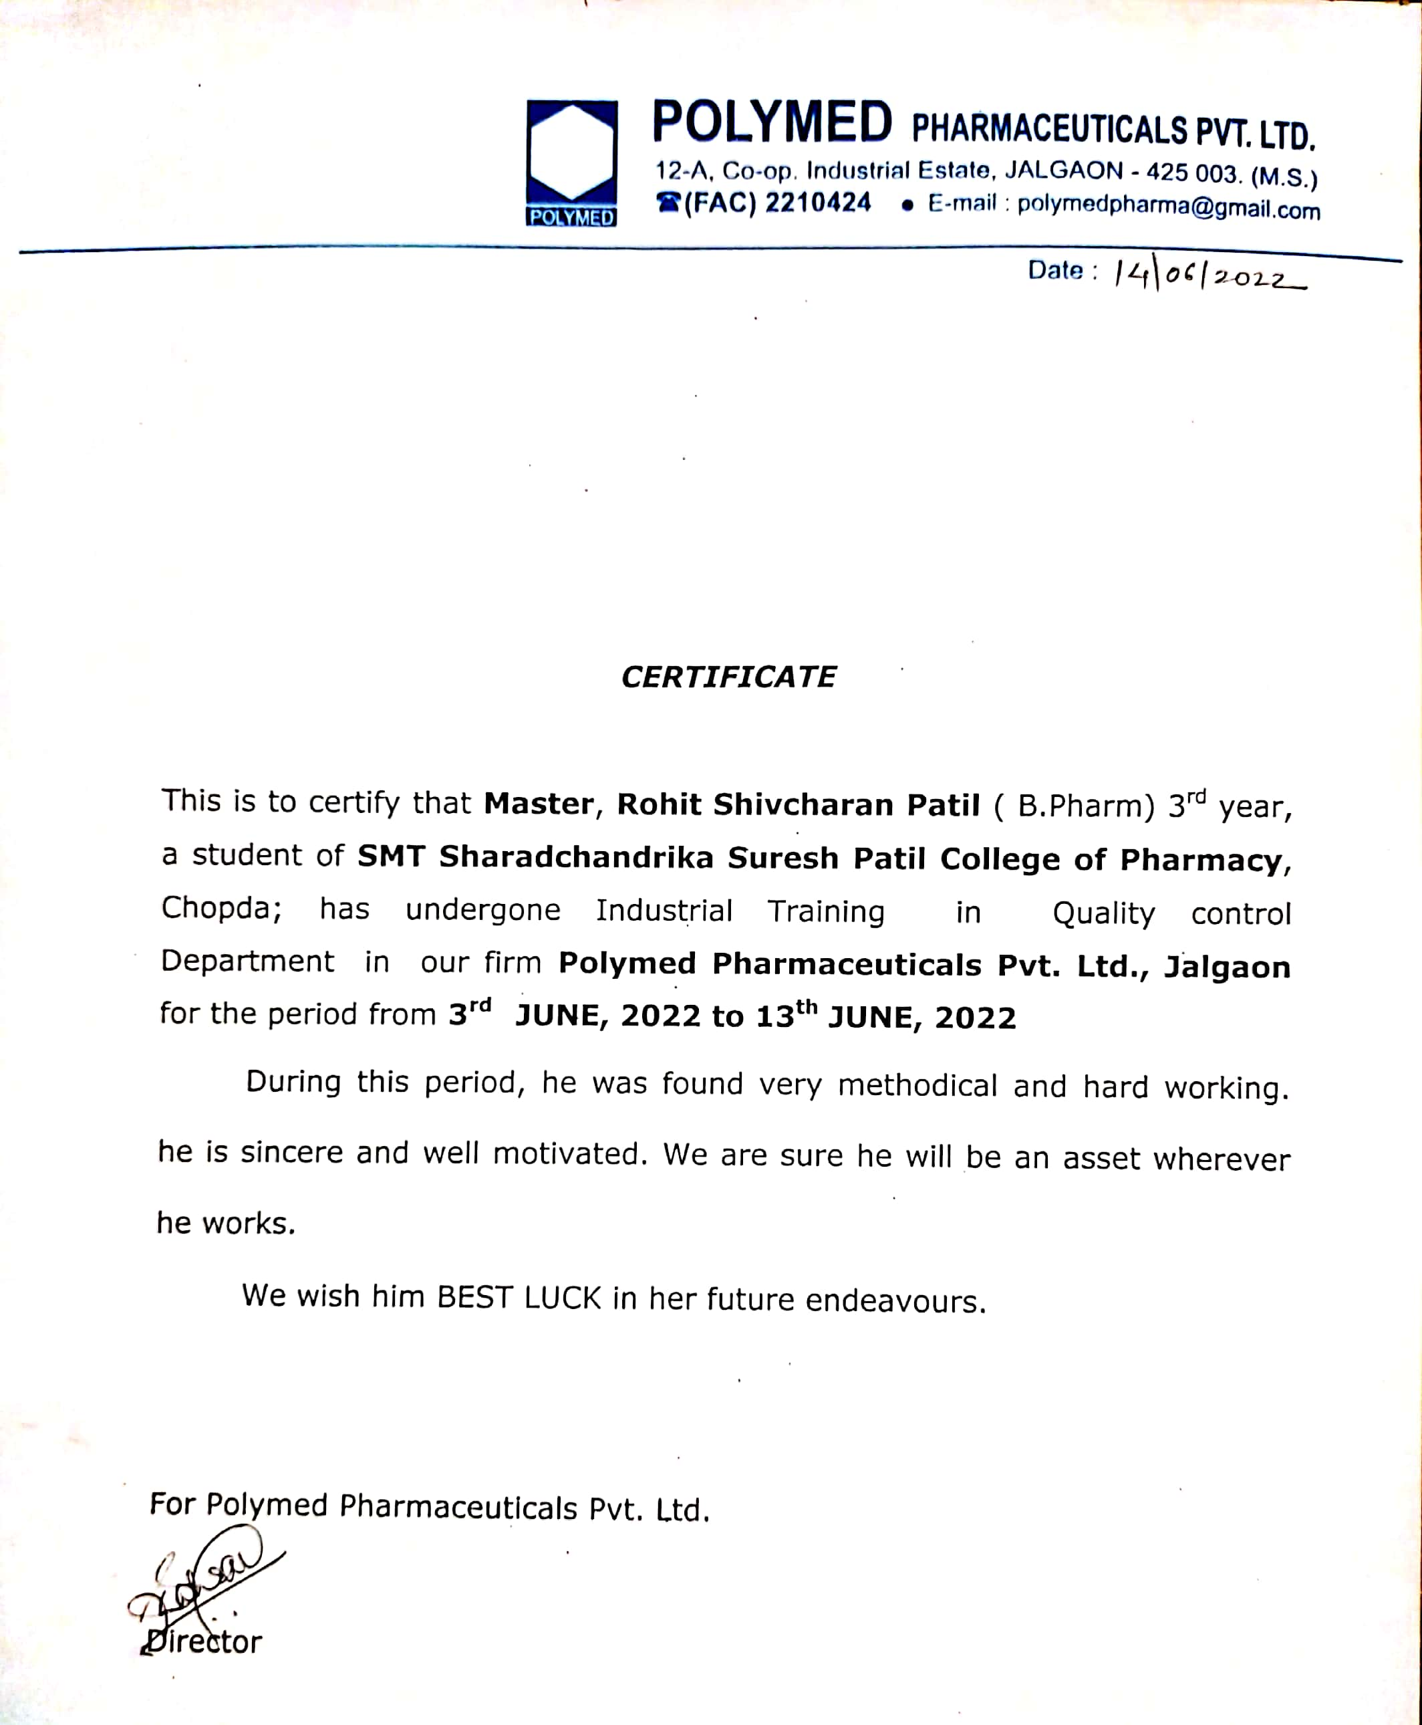

**ACKNOWLEGMENT**

It is a matter of pleasure and happiness to make and submit this industrial training report during course of the completion of this industrial work . Many of the persons have offered their valuable and enormous support .

I'm thankful to all my teachers of SMT Sharadchandrika Suresh Patil collage of pharmacy chopda For their blessings and encouragement .

I would like to express my special thanks and gratitude to POLYMED PHARMACEUTICAL PVT LTD JALGAON and Mr. Sumit kabra for providing all the essential facilities which were required for this training .

Finally , I express my regards to my beloved parents who inspired me throughout my studies and completion of this training .

Rohit Patil .

Third Year B. Pharm

( Sem – 6 th )

**Index**

|  |  |
| --- | --- |
| **SR**  **NO** | **NAME OF CONTAIN** |
| **1** | Introduction |
| **2** | Visions Mission And values |
| **3** | List of Products |
| **4** | Layout |
| **5** | Details about Oral Liquids and parental Doses |
| **6** | Quality Control Section |
| **7** | Equipment |
| **8** | Conclusion |

**Introduction**

**Location** :

Polymed pharmaceutical pvt Ltd

12A co- op- Industrial estate ,

Jalgaon, 425001

**Site capability** :

* Manufacturing Facility- Vitamins & Minerals Premixes Processing , Primary Packing , Secondary Packing , and Sachet filling machine .
* General Tablets Granulation Area , Three Compression cubicles and three packing lines
* State of art Quality laboratory
* Qualified and competent staff Separate Wet and Instrument Lab
* Class 100,000 Microbiology Setup
* Labs are well equipped with latest infrastructure
* USFDA , WHO – GMP , ISO 9001 , 14001 , 22000 , HACCP , SQF , Etc certifications .

**Silent Features :**

**Total Land Area- 35 Acres**

**• Total construction area- 24,500m2**

**• Four separate manufacturing facilities General Tablets**

**➤ Oral liquids , Sugar coated Tablets , and Vitamins & Minerals Premixes for Human Nutrition Health.**

**➤ Vitamins and minerals premixes for Animal Nutrients.**

**VISION , MISSION & VALUES**

**Vision :**

**Polymed pharmaceutical pvt Ltd are the leading healthcare professionals . Polymed pharmaceutical pvt Ltd are leading manufacturer in Vitamins and Minerals Premixes veterinary infectio and Exporter of the same .**

**Mission :**

**We Shall ensure the Quality , reliability , and innovation thereby enhancing the sustainability and values for all stakeholders .**

**Values :**

* **Knowledge- Expertise and Innovation**
* **Action- Entrepreneurship and Integrity**
* **Care- Trusteeship and Humiluty**
* **Impact- Performance and Resilience**

**The values that guide our culture are embodied in our purpose**

**“ Doing Well and Doing Good “**

**List of Products :**

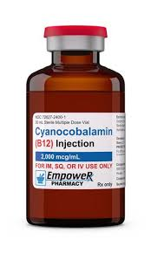**Cynocobalamine (B12) Injection**

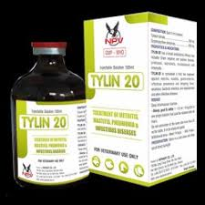**Tylin 20 injection**

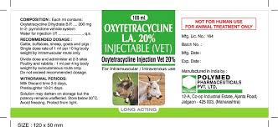**Oxytetracycline injection**

**Urinflow 0.4**

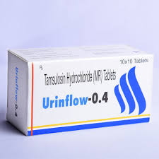

**Syrup Radok of D**

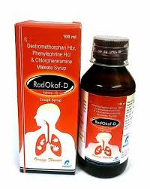

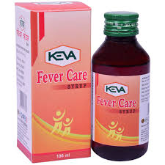**Syrup Fever care**

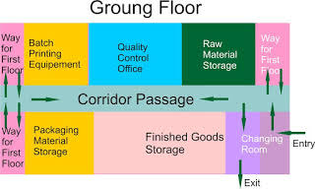**Layout**

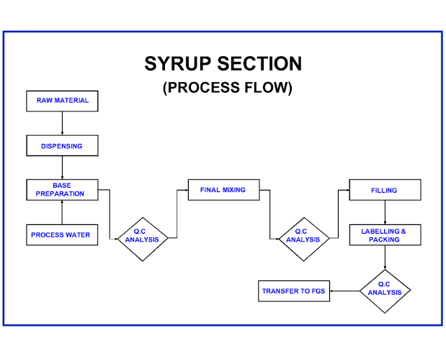

**Orals Liquids :**

Oral liquids are the homogeneous liquid preparations , usually contains a solution , an emulsion or a suspension or one or more active ingredients in a suitable liquid base . They are prepared for oral administration rather as such or after dilution . They may contain other substances such as suitable dispersing , solubilizing , wetting , emulsifying , stabilizing , and antimicrobial substances for preservation

They may also contain suitable sweetening agents , flavoring agents and permitted colored agents . If sodium saccharin or potassium saccharin is used for sweetening , then its concentration in pediatric preparations should not be more than 5 mg per kg of body weight**.**

**Types of Oral Liquids :**

**1. Syrup**

**2. Oral Suspension**

**3. Oral Solution**

**4. Oral Drops**

**5. Oral Emulsion**

**6. Mixture**

**7. Linctus**

**8. Elixir**

* **Advantages of Oral Liquids :**

1. Immediate available for absorption .

2. Easy administration

3. Bitter drugs can be given by this route

* **Disadvantages of Oral Liquids :**

1. Less stable compare to solid dosage forms . 2. They are bulky and difficult for store and transport

3. Incompatibility is more .

**Oral liquid :**

**Steps for manufacturing of oral liquids**

1. Planning of Material Requirement

2. Liquid Preparation

3. Filling

4. Labeling

5. Packaging

6. Sales of Drug Products

The above mentioned steps are usually involved in the manufacturing of the oral liquids formulations in stepwise manner . Each step has its unique role in the process of manufacturing of the pharmaceutical oral liquid dosage form .

The most important step in the manufacturing is the planning of material requirement it usually done by the quality peoples . By the proper planning one can set the benchmark for the manufacturing . Liquid preparation is another step which is play important role . Here the 75 % of work is done of the manufacturing of oral liquid . Then filling and labeling are also done with the help of labor assign to the same purpose .

After labeling packing is done to ensures the products used for the mankind . Lastly the most important phase of the oral liquid manufacturing is get performed called sales of the drug products.

**List of the equipments used in the manufacturing :**

1. Mixing and storage tank

2. Portable mixer

3. Colloid mill

4. Filter press

5. Semi automatic bottle filling machine

6. Water still

7. Labeling Machine

**Formulation of Oral Liquids :**

1.Drug and range of excipients includes a ) The vehicle : purified water and oil

2. Co – solvents : Propylene glycol and glycerine 3. Surfactants : To enhance the surface activity 4. Preservatives : Used against microbial contamination

5. Sweetening agents : Glucose , saccharin , aspartame

6. Buffering agents : To regulate the pH of formulation

7. Antioxidants : BHA and BHT

**Evaluation of Oral Liquids :**

1. Uniformity of content

2. Uniformity of weight and volume

3. Test for bacterial endotoxin

4. Leaker test

5. Pyrogen test

6. Clarity of solution .

**Quality Control Section**

It is the essay method in substance such as drugs , packing material , raw material , adjuvant , containers are checked according to the monograph as per standards given to the pharmacopoeia .

**Following are the equipments used in QC section :**

1. Magnetic stirrer

2. Electronic and simple balance 3.

4 pH meter

5 Autoclave

6 UV and visible spectrophotometer

7 Leaker test apparatus

1. **Autoclave :**

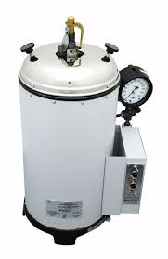Autoclave is a device used to sterilize the equipment and supply by subjecting them to high pressure saturated at 121 degree Celsius for around 10-15 minutes .

**2) pH meter :**

A pH meter an electronic device used for the measuring the pH of liquid formulation . A typical pH meter consist of a special measuring probe connected to an electronic meter that measure the display the pH reading **.**

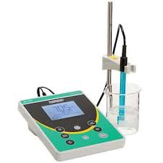

**3. UV – Visible Spectrophotometer :**

UV Visible spectrophotometer is used in pharmaceutical industry due to its various applications . It is one useful in detection of impurities , Food industry , forensic science , qualitative and quantitative analysis are carried out with the help of the same .

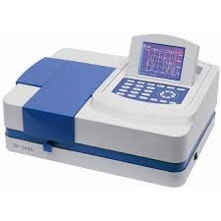

**CONCLUSION**

In the end I am glad to tell you that training in POLYMED PHARMACEUTICAL PVT LTD JALGAON was an excellent and fabulous experience . During the training I actually learned about the Pharmaceutical company and above its working the theoretical knowledge is worth for getting a degree , and it is accessible in the book . We can only imagine about the thing we read , but practical life is always different and excellent one . During My training period , I had seen the various instruments and apparatus in the industry . The highly sophisticated instruments that work precisely must be operated with intense care for optimum use . We could acquire a lot of information regarding the latest instruments and their working procedures .

Similarly from practical point of view a pharmaceutical company is very difficult . During the training session I tried to my level best to gain practical knowledge as much as I can . I improved my basic classified doubts and also understood the importance of maintaining of quality of products at Pharmaceutical company .

I was successfully able to complete my short venture of training . Lastly I hope that my training report fulfill the intended requirements .

**Regards**

**Rohit Shivcharan Patil**

**Third Year B Pharm**

**( Sem - 6th)**

